

YEAR: 7
SUBJECT: SCIENCE

TEST: Forces
TIME: 40 minutes
QUESTIONS: 5 Multiple Choice (5 marks)
7 Short Answer (20 marks)

TOTAL MARKS: 25 marks

DO NOT WRITE ON OR MARK THIS PAPER
SECTION ONE – MULTIPLE CHOICE (20 marks)
This section has 5 questions. Answer all questions on the separate multiple-choice answer sheet provided.

1. Force is measured in
a. kilograms
b. litres
c. tonnes
d. newton

2. Which of the following is a contact force?
a. electrostatic
b. magnetism
c. friction
d. gravity

3. Which of the following is ONLY a pulling force?
a. electrostatic
b. magnetism
c. friction
d. gravity

4. All cars, bicycles and automobiles have brakes to make them stop. Brakes work by increasing the
a. gravity
b. friction
c. mass
d. weight

5. A block suddenly moves across the table. The reason why it moves is:
a. there is very little gravity
b. there is a force applied to the block
c. magic
d. friction

ANSWER BOOKLET

NAME:

FORM: DATE:

Multiple Choice Short Answer Total

/5
/20

/25

/20
/25

SECTION ONE: Multiple choice answers
Cross (X) through the correct answer.
1 | a | b | c | d
2 | a | b | c | d
3 | a | b | c | d
4 | a | b | c | d
5 | a | b | c | d

SECTION TWO: Short Answer (20 marks)
1.
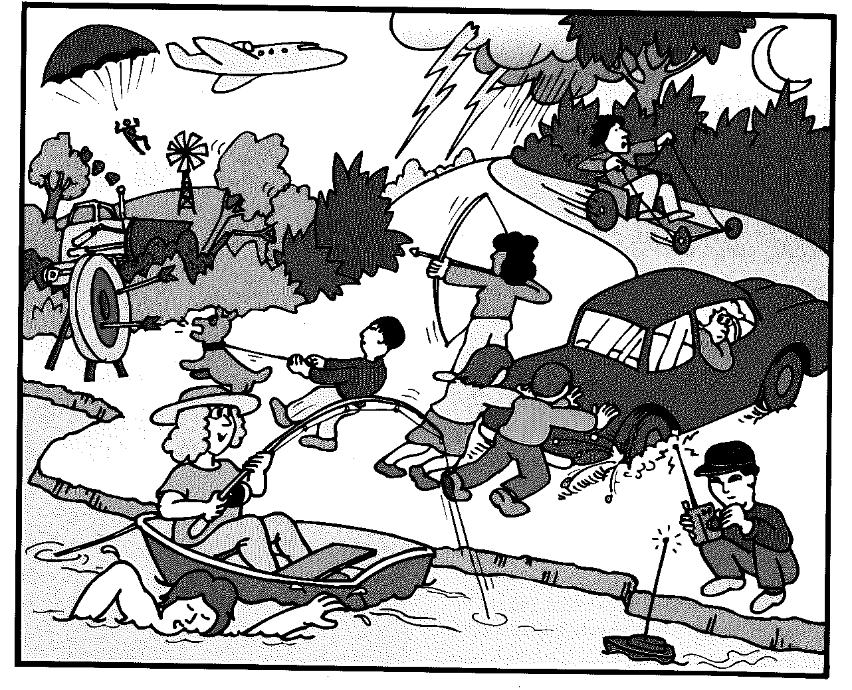
- Circle in the picture an example of a push force (1 mark)
- Put two crosses in the picture where there are examples of a pulling force (2 marks)
2. Match the definition of terms to the words ( i to iii).
(3 marks)
a) gravity | i) a force that is the downward pull of gravity on an object
b) mass | ii) a force that pulls two objects with mass together
c) weight | iii) is the amount of matter in an object

3. Johnny put 2 magnets close to each other. Describe what would happen if
a) Two North Poles were facing each other (1 mark)
________________________________________________________________________
b) A North and a South Pole were facing each other (1 mark)
________________________________________________________________________
c) Two South Poles were facing each other (1 mark)
________________________________________________________________________
4. a) List 2 ways that you can reduce friction (2 marks)
________________________________________________________________________
________________________________________________________________________
b) Name one reason why you would want more friction (1 mark)
________________________________________________________________________
________________________________________________________________________
5. True or False (4 marks)
a) If the forces acting on an object are balanced then it is not moving. ______
b) Gravity is a contact force _________
c) An object moving at constant speed has an unbalanced force _______
d) Magnets only have a repelling force _______
6. Determine whether the object forces are balanced or unbalanced by circling one. (4 marks)
a) Balanced / Unbalanced
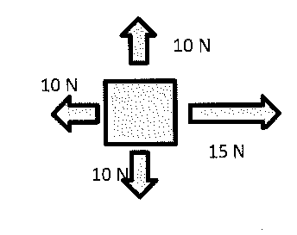
b) Balanced / Unbalanced
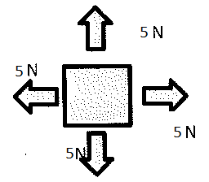
c) Balanced / Unbalanced
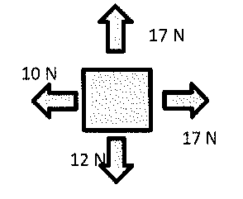
d) Balanced / Unbalanced
